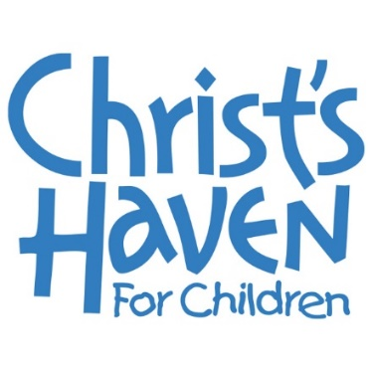
Christ’s Haven for Children
Development Manager
Job Description

Christ’s Haven for Children provides a warm, loving, Christian environment in which children in need of basic care can grow physically, emotionally, and spiritually. Our ultimate goal is to provide love and support to families in need. Our trauma-informed, family based model of care allows for our children and teens to be confident as they heal from past trauma and envision a bright future.
Position Overview: Reporting to and in partnership with the Director of Donor Relations, the Development Manager will be responsible for annual giving initiatives, public relations, grant writing, and donor cultivation/stewardship.
Christ's Haven for Children is a Christian non-profit ministry that serves children in need. This position will serve those children by performing the following duties:
- Annual Giving Management
  - Execute campaigns outlined in the annual communication plan related to Child Abuse Prevention Awareness Month, NTGD, Giving Tuesday, and others
  - Execute direct mail strategy to achieve goals (4-5 annually)
  - Implement recurring gift strategy
  - Develop strategy for third party fundraising initiatives and peer-to-peer fundraising initiatives

- Fundraising/Donor Relations
  - Donor stewardship of assigned donor portfolio
  - Cultivate donors and identify new ones with regional businesses, civic groups, churches, and individual supporters. Leverage prospect management and prospect best practices.
  - Utilize Salesforce to log and track all activity with all constituents

- Grant management
  - Assist Director of Donor Relations with grant research, writing, management and stewardship

- Public Relations
  - Represent the organization at events and programs
  - Become an active member of chambers and attend events to help create awareness

- Additional Responsibilities
  - Work with development team to arrange tours and follow up with key constituents.
  - Assist other organization employees as needed.
  - Other special projects as identified

Skill Requirements and Competencies:
- Communications: Strong organizational and interpersonal skills. Excellent verbal and written communicator with ability to express ideas and thoughts clearly.

- Technical Skills: Proficiency in Microsoft Excel, Word, PowerPoint and database management (preference for Salesforce)
- Achievement Focus: Demonstrates persistence and overcomes obstacles. Measures self against standard of excellence. Recognizes and acts on opportunities. Sets and achieves challenging goals.
- Professionalism: Must be confident, organized, articulate and poised with the ability to represent CHFC as an organization.
- Leadership and Ethics: Inspires others and upholds organizational values. Commits to doing the best job possible and works with integrity and respect. Reacts well under pressure. Shows courage to take action.
- Dependability: Punctual, reliable and willing to go above and beyond for the good of the team. Must have a positive attitude.
- Innovative: Develops new approaches and ideas, displays creative thinking and willing to take on new challenges.
- Time Management: Uses time efficiently and works in organized manner. Capable of prioritizing tasks, motivating team members, delegating projects and juggling competing priorities in fast-paced environment. Able to work independently and simultaneously on multiple projects, balancing team and individual responsibilities.
- Strategic Thinking: Helps to develop and manage strategies to achieve organizational goals.
- Teamwork: Contributes to building positive team spirit, puts success of team and organization above own interests

Special Requirements:
Local travel for meetings and volunteer support activities as requested and occasional evening and weekend work. Some early mornings and late evenings required.

This position requires the ability to set up and run meetings and events. As such, individuals should be able to meet physical demands of standing for long periods of time and be able to lift up-to twenty pounds.

Work Experience:
Must have demonstrated success in a development position or in related field with a minimum of 5 years’ experience. 4-year college degree required.

Please send resumes to Lisa Fandrich at lisa@christshaven.org

